# Lab NO : 1

## Overview Of Machine Learning pipeline and setup

## Objective

To provide hands-on experience with Python installation, environment configuration, and exploration of essential tools and resources necessary for machine learning applications. This lab also focuses on preparing students to access relevant materials, datasets, and platforms to support their learning journey in AI and data science.

## Tools and Resources Used

|  |  |
| --- | --- |
| Tool/Platform | Purpose |
| Python / Anaconda | Environment setup and coding interface |
| GitHub | Version control and code collaboration |
| Jupyter Notebook | Writing and testing Python code interactively |
| Google Colab | Online execution of Python scripts without installation |
| YouTube / Coursera / GitHub | Educational resources and project examples |
| Stack Overflow / Real Python | Community support and expert tutorials |
| Datasets (Kaggle, GitHub, AICrowd) | Data for practice in ML and forecasting |

## Lab Tasks and Activities Performed

* 1. Installed Python from the official website and/or Anaconda for managing environments.
* 2. Created and configured a GitHub account for version control and code storage.
* 3. Explored community resources like Stack Overflow and Real Python for debugging and learning.
* 4. Practiced using Jupyter Notebook by writing and executing sample Python code.
* 5. Set up a virtual environment using venv or Anaconda to manage project dependencies.
* 6. Used Google Colab to execute Python scripts directly in the cloud.
* 7. Accessed video tutorials and sample repositories to understand OOP and Python basics
* 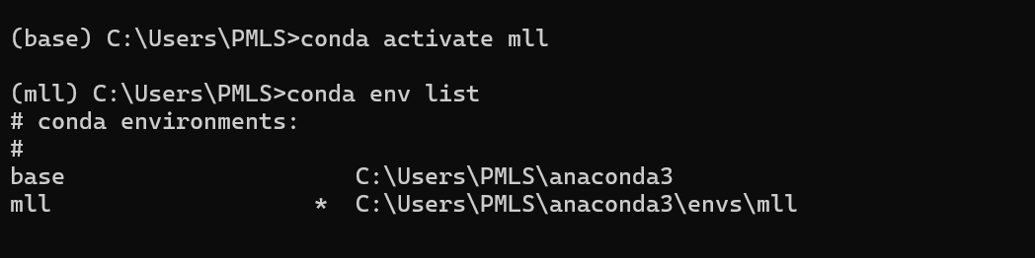.

## Machine Learning & Deep Learning Resources

* ML Specialization – Coursera course by Andrew Ng.
* Lecture notes from irosyadi.netlify and videos from StatQuest (YouTube).
* Deep Learning Specialization on Coursera.
* Time-series forecasting references from shared OneDrive folders.  
    
  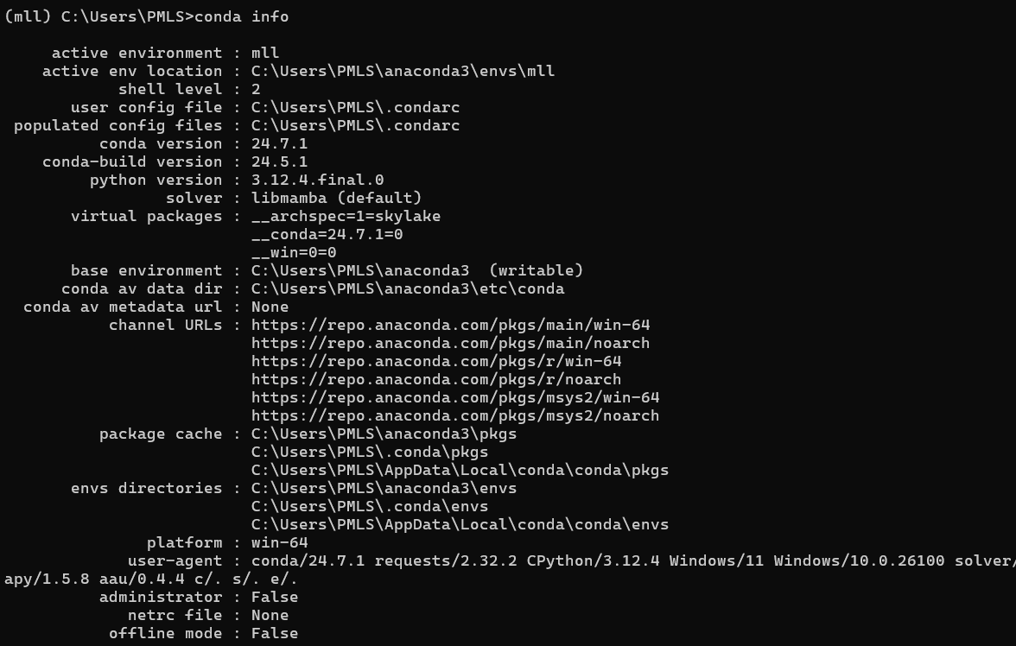

## Important Python Libraries

* NumPy – Core library for numerical computations (YouTube tutorial available).
* Pandas – Essential for data manipulation and analysis (YouTube playlist).

## Recommended Books

* Python Tricks: The Book by Dan Bader
* How to Think Like a Computer Scientist by Allen Downey
* Deep Learning for Time-Series Forecasting by Jason Brownlee
* Deep Learning by Ian Goodfellow
* Deep Learning with Python by François Chollet

## Conclusion

This lab session provided a strong foundation for working with Python and understanding its relevance in modern-day machine learning and AI applications. Students became familiar with environment setup, virtual environments, Jupyter Notebooks, and Colab. Additionally, they explored key learning platforms, libraries, and datasets which will support the development of future forecasting and deep learning models.